The Tinkering Toyshop
1st Grade Design Brief

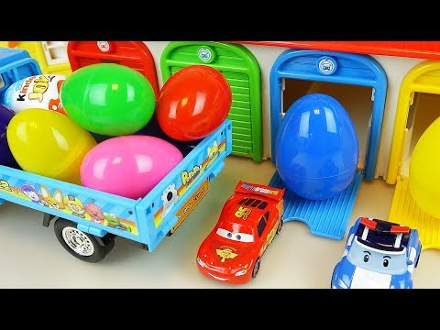
Background:
We have been learning that objects can move in different ways - straight, circular and back-and-forth motions - and that pushes or pulls can change the movement of an object. We also have been learning about the Engineering Design Process and that we can observe the impact of the things we make.

Challenge:
Your challenge is to design a toy that moves by being pushed, pulled or spun and results in one or more of the following movements: straight, circular or back and forth.

Criteria:
- The toy moves by being pushed, pulled or spun.
- The toys moves in one or more ways: straight, circular or back and forth.

Materials:

- craft sticks (10)
- pipe cleaners (2)
- rubber bands
- wire
- string/yarn
- marbles
- CDs
- balloons
- pompons
- feathers
- tinker cart supplies (limit 4)

Tools:

- scissors
- wire cutters
- Crop-O-Dile/hole punch
- masking tape
- paper fasteners
- tacky glue
- Easy Cutter (ask teacher)
- glue gun
- markers and Sharpies
- stapler

