What’s the Matter?
3rd Grade Design Brief

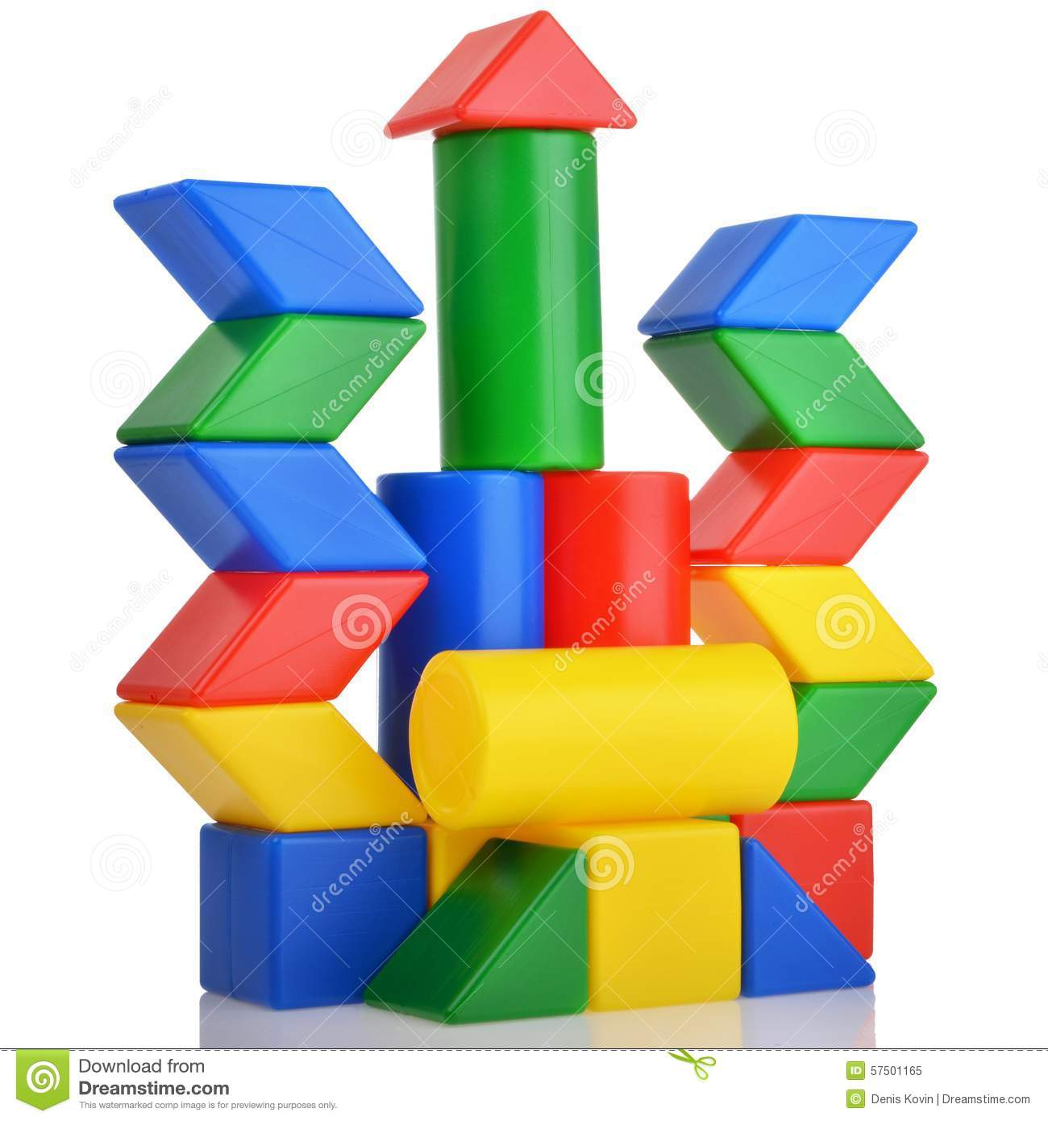
Background:
We have been learning that objects can be made of one or more materials and described by their physical properties. We also have been learning about structures and the Engineering Design Process. You are invited to select two items from the tinker cart to bring back to your group. Work together to sort the items, grouping them by similar properties.

Challenge:
Your challenge is to work as team to design and build a tower that represents one property. Keep your property a secret so that other groups can guess your property.

Criteria:
- The tower contains at least 10 materials from the tinker carts that share the same property.
- The tower is at least 12 inches tall.
- The tower stands up on its own.

Materials:

- 10-15 items from the tinker carts
- 1 item to serve as the base
- pipe cleaners (4)
- rubber bands
- wire
- string/yarn

Tools:

- scissors
- wire cutters
- hole punch
- paper punch
- masking tape
- tacky glue
- glue gun
- stapler

