Paper Structures
Design Brief for Grades K-5

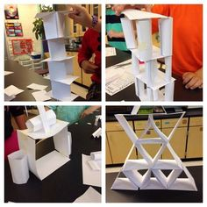

Background:
We have been exploring ways to build up. Think about what has worked and what has not worked. Should your base be large or small? How can you connect and combine materials to build walls and floors? What do walls need to stand up?

Challenge:
Your challenge is to build the tallest tower out of copy paper and scotch tape.

Criteria:
- Your tower is constructed only out of copy paper and scotch tape.
- Your tower stands on its own for 30 seconds.

Materials:

- 10 pieces of copy paper
- 1 roll of scotch tape

Tools:

- ruler or yardstick

